- Use Google PageSpeed Insights to analyze the homepage of your favorite food delivery app (like Zomato or Swiggy) and note down its LCP, INP, and CLS scores.
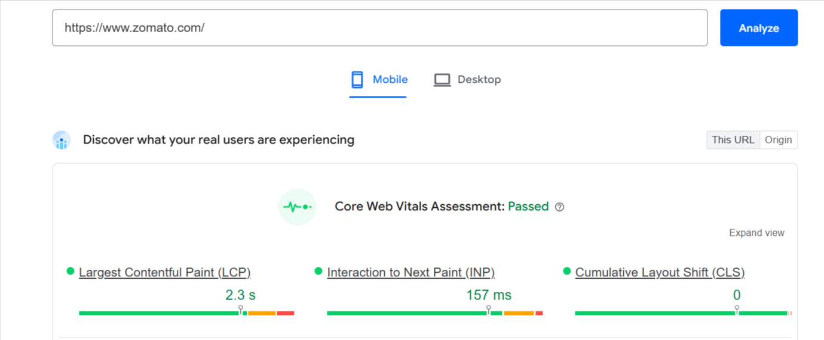
- Add a simple caching rule to your website by editing the .htaccess file to set browser cache for images to 1 month.<br><br><em><strong>Hint:</strong> Use 'ExpiresByType image/jpeg' and 'ExpiresByType image/png' directives.</em>
# Browser caching for images - 1 month
<IfModule mod_expires.c>
ExpiresActive On

ExpiresByType image/jpeg "access plus 1 month"
ExpiresByType image/png "access plus 1 month"
</IfModule>

- Create a table listing what LCP, INP, and CLS mean, and for each, give one real example of a bad user experience from an app you use (like Flipkart, Instagram, or BookMyShow) when that metric is poor.
Metric | Full Form | What It Means | Example of Bad User Experience
LCP | Largest Contentful Paint | Measures how quickly the main content of a page becomes visible. | Flipkart: You open a product page, but the main product image takes several seconds to appear. You see a blank/loading area and may leave the page.
INP | Interaction to Next Paint | Measures how quickly a website/app responds after you interact with it, such as clicking or tapping. | Instagram: You tap the Like button, but the interface takes a few seconds to respond. It feels slow or unresponsive.
CLS | Cumulative Layout Shift | Measures how much the page unexpectedly moves while loading. | BookMyShow: You are about to tap a movie/show button, but an advertisement or image loads and pushes the button downward, causing you to tap the wrong thing.

